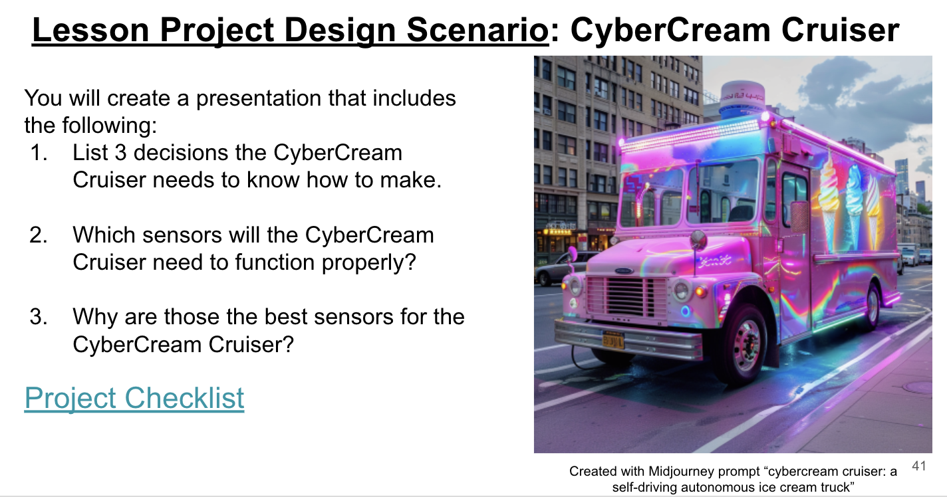
Instructions: Check off each item on this checklist as you complete your CyberCream Cruiser project.
Category | Requirement | Completed (✓)
Learning Target 1: Sensors on a Self-Driving Car  **Examples of Sensors to Include  Lidar  Radar  Cameras  Ultrasonic sensors | Include at least three types of sensors used in self-driving cars.
 | Describe what each sensor does.
 | Explain where each sensor is located on the car.
Learning Target 2: Decisions/Subsystems of a Self-Driving Car | Explain at least three types of decisions the car must make.
 | Describe how the car processes information to make these decisions.
 | Explain at least three subsystems within the car.
 | Describe the role of each subsystem.
Specific Requirements for Canva | Use a combination of text and images to explain the concepts.
Specific Requirements for Canva | Include at least five slides or pages.
Specific Requirements for Canva | Ensure each slide has a clear heading and is visually balanced.
Specific Requirements for Comic Creator | Create a comic strip that includes characters explaining the concepts.
Specific Requirements for Comic Creator | Use at least six panels.
Specific Requirements for Comic Creator | Ensure speech bubbles are clear and concise.
Specific Requirements for Scratch | Create an interactive project or animation.
Specific Requirements for Scratch | Include buttons or actions that allow users to learn about each sensor and decision/subsystem.
Specific Requirements for Scratch | Ensure the project runs smoothly and is user-friendly.

